# The Shopping Mall Design Requirements

The Estates are looking to build out our marketplace, called The Shopping Mall, starting development now. The purpose of this document is to provide some guidance to the requirements for the build, along with keep it as a living document. This is going out to tender and a selection will be made soon.

1. Upfront costs, an itemised breakdown is preferred. All quotes are to be made in $AUD.
2. Expected delivery time with guarantees will be weighted heavily in the decision making process. We want this marketplace up and running in a timely manner, ideally in less than 4 weeks, at least the $EQUITY based purchases.
3. What your solution will be to achieve the requirements set out in this document.
4. Having the marketplace inventory be manageable by The Estates team easily is imperative here.

In terms of delivery dates and times and budget:

1. Phase 1: Ideally less than 4 weeks
2. Phase 2: 2 weeks from Phase 1
3. Phase 3: 2 weeks from Phase 2

Note: “Items” and “assets” are different things here. “Items” are objects/3D models purchased from The Shopping Mall, including things like chairs, tables, sculptures, etc. “Assets” are the metadata assets of The Estates NFTs themselves, so the metadata from the original NFT collection.

## Phase 1) $EQUITY based purchases

The goal for this marketplace, called The Shopping Mall, will be for items to be purchasable for the staking token $EQUITY, and then once purchased to be attached to the NFT and to follow the NFT if it is sold to a new holder. The goal here is to have the ability for an NFT to “gain value” by way of using the staking token $EQUITY to improve their Estate.

In addition arbitrary items will need to be added, like WLs, raffles for NFTs etc.

All Shopping Mall items will have a #number and be stored in our S3 database, this is relevant for the lookup ability to find these items and download them when they have been purchased, based on the NFT that owns them.

Note: In the future, 2 NFTs will be able to be burnt and combined. When this occurs, then will need to be a way to combine the associated items from the two previous NFTs to their new ID. For example, NFT #200 and NFT #400 combine to make NFT #9000. Now, all items purchased by #200 and #400 will need to be now associated with NFT #9000. I believe the easiest way to do this would be to have either the information copied at time of creation to #9000, or a lookup field that includes the two previous.

### Workflow:

1. User signs in with wallet
2. Marketplace reads wallet and detects Estates NFTs present (not sure of best way to do this, will need to be able to look at staked NFTs also. Could get the same wallet connection from the Front-end Dev which does this already on the inventory page on <https://app.theestates.io/#/inventory>)
3. User selects items from the store they wish to purchase for $EQUITY
4. User selects which NFT they will be purchasing on
5. Transaction is created, when approved $EQUITY is debited/burned and next steps occur
6. Shopping Mall Database (SMD) with list of NFTs and items that belong to each NFT is updated to reflect purchase and a log of the transaction is created
7. Access to download purchased items is granted immediately to NFT (not the wallet) through a permission to our S3 database (can be achieved through a smart item numbering system)
8. User can download items from The Shopping Mall/Blueprints site.

### Important factors to include:

1. Anyone (including the public) must be able to look at any NFT # in the collection and see what items are associated with that NFT easily. This way when thinking of purchasing an Estates NFT, anyone can easily check to see what items have been purchased.
   1. Bonus if it is possible to update the metadata of the NFT also, that would be a great addition. Potentially it could update to a spreadsheet and we could manually update the metadata once a week to reflect these purchases.
   2. Being able to filter by purchased
2. There needs to be the ability for The Estates team to easily add new items to The Shopping Mall and manage its content securely. There will potentially be new items being added every week and could end up with 100s, maybe even 1000s, of items in there. So a straight forward management system
   1. Explicitly, a point-to-click interface where a non-technical team member could upload a 3D file, its display picture, title, description, item number, number available, $EQUITY cost, time available (or ongoing). Additions should automatically populate in 2b.
   2. An easy to understand backend which is automatically updated as items are added and sales made
   3. The process outlined in 2a should also be able to be managed from a backend standpoint, to allow for editing of parameters, as well as bulk adding items etc.
3. Classic functions like limiting the number of buys possible, the timeframe an item is available for and being able to put an item on “SALE” for a limited time are all needed.
4. Community created items are also in the roadmap. What this means is that if a community member wants to create an item and list it, then that is possible. The Estates would need to curate the item and decide whether or not it should be listed. In the situation where this occurs, a % of the sale would go to the creator, so would need to be able to have the ability to either define where the sales $EQUITY/eth goes for these items, or to have a good log method that would allow The Estates to do disbursements easily once a week for example.
5. A log for items sold that is backed up daily. This file should be usable to recover the database if needed.

## 

## Backend Layout Explained: For example:

An item on the marketplace is created:

1) The item number should be visible for this item in the admin panel.

2) The item number should be created based on the item type, not 1, 2, 3, 4 etc. So if it is a table, it could be TBL00001. If it is a chair, it would be CHR00001, if we create a second chair, then it would be CHR00002. So this way, all items are broken up. It would be really ideal if, on the admin panel, we could create our item types, like chairs, tables, stools etc., then we gave them an item type, and this would be the first three letters, then the last 5 are the item number. For example, chairs are CHR. That means that the first chair would be CHR00001, the second chair would be CHR00002, the 2432 chair would be CHR02432 etc. This allows for many different item types, and many different item variations. If desk lamps are DLP, then the first desk lamp would be DLP00001, and so on. This should all be reflected in the metadata.

It will be much easier to do 3 letters at the beginning for the item type, like CHR for chair, TBL for table, etc. So it could be CHR0001, TBL0001, DLP00001 etc.

3) On the admin dashboard, we should be able to see who has purchased any given item, so that in the case where there is an issue, we can easily look up if a purchase was made or not (also, if there is a case where someone loses their wallet, we could transfer the item ownership.

3b) This would also allow us to add wallets to an item. For example, 10 people win a giveaway for chairCHR00014, we can simply add these 10 wallets to the item ownership page and it will show up on their wallet when they connect

4) An easy to read list of all the item numbers, then their information, like title, item number, number in stock etc., all in one big list, so we can real time look and manage all items. At the moment there is that page which shows all the items, this is great, but doesn't display all the data. For all of this, just imagine it if we had 10,000 items plus, how easy it would be to manage. If it would take 5 minutes to scroll and find an item, that is way too hard. It needs to be simple and easy

So, for example, the below table would change from:  
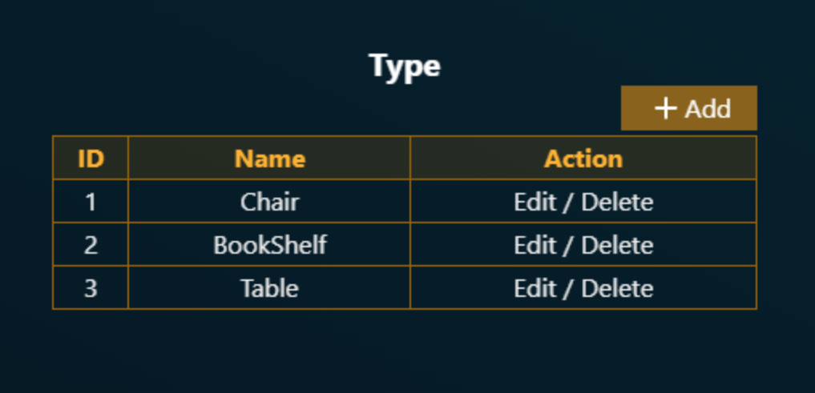  
Into the following example:

Table 1: Type Example

| **ID #** | **Identification Code** | **Name** | **Action** |
| --- | --- | --- | --- |
| 1 | CHR | Chair | Edit / Delete |
| 2 | BKS | Bookshelf | Edit / Delete |
| 3 | TBL | Table | Edit / Delete |

What this means is that when we make a new TYPE, being a Chair, Bookshelf, Table, Lamp, Shoe etc., they are identified by three letters, which we choose.

Now, for when we create a new item, there are 2 new fields, “Type” and “Number”. Have a look at the examples below to see:  
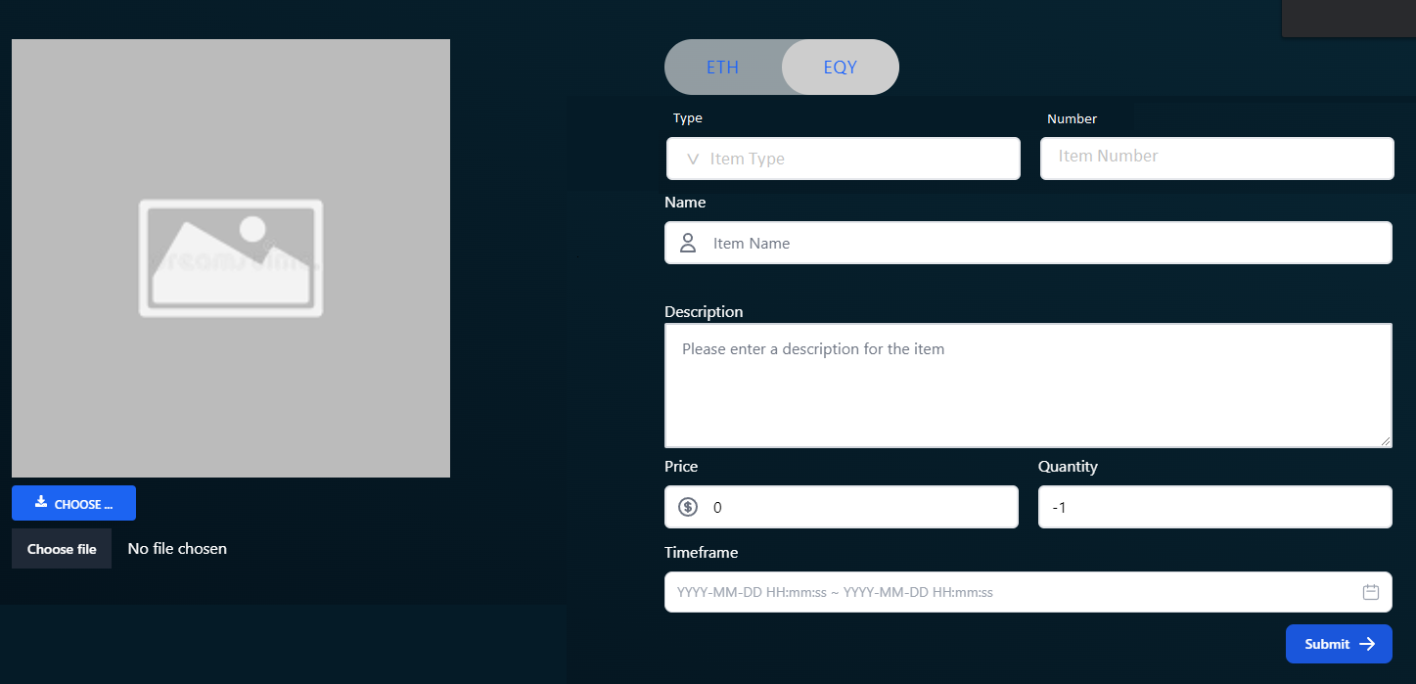  
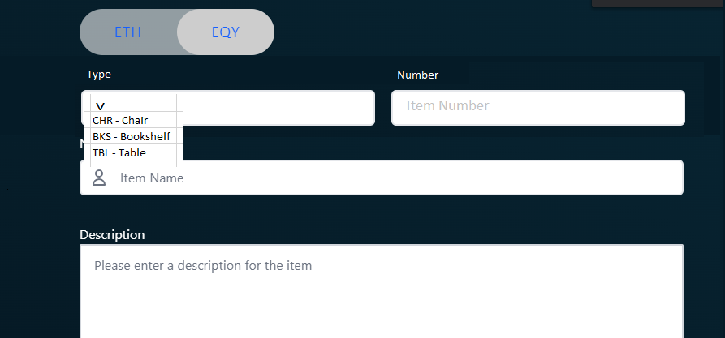

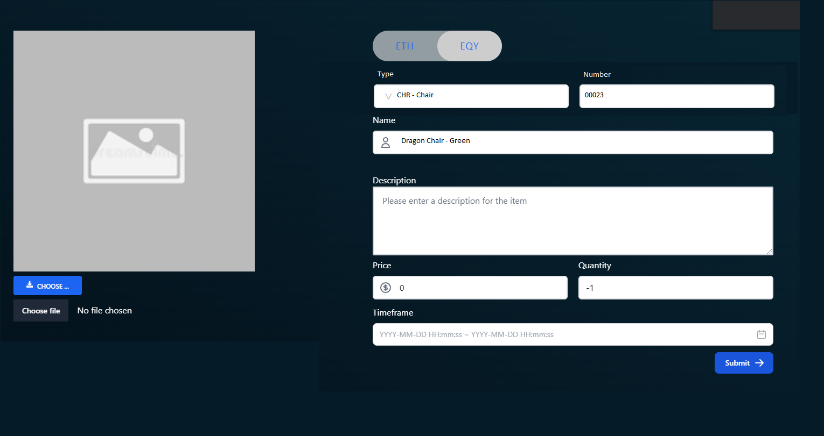

In this example, Type is a dropdown box with the examples from Table 1 above, which are delivered in the format of the three letters, a “-”, and then the name. So, CHR and Chair, become CHR - Chair.

When selected, the “Number” field is automatically populated with the next number in the CHR sequence, in this case 00023. This will result in the metadata title for this item being CHR00023.

So total Metadata would be, for this item:  
  
TYPE: CHR

NUMBER: 00023

NAME: Dragon Chair Green

METADATA: CHR00023_img_Dragon_Chair_Green.img & CHR00023_glb_Dragon_Chair_Green.glb etc.

Also, in our discord chat, we spoke about how to do the backend management. If you go to our comments on 12/03/2022 2:35 PM up to 12/03/2022 2:51 PM where we spoke

## Phase 2) Ethereum based purchases

We may want the option to be able to have certain items available for ethereum purchase, most likely as weekly auctions. Is there a way to accomplish this? May need to be in WETH, however ETH would be much much better.

These items would most likely then be airdropped/minted to the winners wallet as an ERC item so that they can then be on-sold. Could be part of a new collection called something like “The Estates Shopping Mall Items” or similar.

## Phase 3) Upgrading, Redecorating and Renovating

The most delicate and complex part for The Shopping Mall will be the Upgrading and Redecorating mechanics, known as Renovating. For more information, please refer to the end of this document for our write up on these processes.

This aspect does not need to be delivered for at least late-September, mid-October.

### For Upgrading to occur correctly:

1. There needs to be a transaction where two NFTs of the same level are burned
2. The metadata of these two NFTs is collected and sent in an easily readable way to an email address (so that the asset creators can generate the required Render, 3D file and metadata files and upload to S3)
3. The list containing the items purchased from these two NFTs will be combined, as previously stated above, so that the new NFT has these items associated with it and downloadable to the holder
4. A new NFT minted on The Estates contract into the purchaser’s wallet (updated at a later date with Render, 3D file and metadata)

### For Redecorating to occur, the process is much simpler:

1. The holder selects the Estates NFT they wish to Redecorate
2. The full list of all assets associated with the two NFTs, which was collected in a list at the time of the Upgrade, will be shown to the holder.
3. The holder selects from this list which assets they want to have displayed on their Redecorated Estate
   1. Some assets will have to be grouped. For example, they can only select on Roof Type, one Roof Colour, one Gate Type etc. So once they have selected one, so these need to be grouped and only one selectable. In contrast, they may be able to select up to 5 Garden features, like the Bike, Pool, Stone bench etc.
4. To confirm their selection, a transaction is generated and approved, the $EQUITY is debited.
5. A new ticket it generated on a job board, which should be public, to show this transaction having been created and what the selections were
6. The House Development Team in Egypt has access to this job board and should be able to see the selections to then generate the 3D files and renders
7. These files will then be uploaded to a different folder on S3 and be a slave file to the NFT they are associated with, much in the same way as items purchased using $EQUITY

## **Renovating**

Renovating your Estate is a process whereby you exchange $EQUITY to either Upgrade or Redecorate your Estate.

There are a number of different ways to Renovate your Estate, including Upgrading and Redocorating.

### **Upgrading**

Upgrading your Estate NFT is a type of Renovation whereby the Homeowner is taking their Estate to the next level. To achieve this, you will need 2 Estates of the same level, as well as the requisite amount of $EQUITY to Upgrade. The Upgrading process will then burn these two Estate NFTs, along with the requisite $EQUITY, and immediately airdrop you a next-level NFT, which, when created by The Estates team, will allow you to refresh your metadata to reveal your Upgraded Estate NFT and download your new Blueprint 3D file.

There will be a Job Board (name TBA), that will show a list of all Upgrades currently in queue, as well as current expected wait time. This is to ensure complete transparency of this process and to allow for holders to time their upgrades when gas is low, the queue is short etc. It is estimated that the turnaround for metadata and model will be 1-3 business days, depending on availability.

Your Upgraded Estate will be bigger, grander and more diverse than before. Assets displayed will be chosen based on highest rarity from the two lower-level Estate NFTs. In the case of two assets being of the same rarity, the trait that will be displayed will be random. In addition, all non-displayed traits will still be attached to your new, higher-level, Estate NFT and can be selected for display by Redecorating, read more below.

In addition, there will be many hidden traits that will only reveal themselves at higher levels. Wondering what the purpose of that random item is in your garden? Just wait and see, nothing is by chance in this project…

#### **Asset combination**

It is possible to combine asset styles to create a diverse Estate that reflects your taste and style. To create a lvl.2 Estate for example, two lvl.1 Estate NFTs must be combined. For lvl.3, two lvl.2 Estate NFTs must be combined. What this means is, if the Homeowner decides to join two lvl.2s of different types together to Upgrade to a lvl.3, their lvl.3 will display assets from both styles. Therefore, you can make any combination that suits your fancy, maybe even mix all 4 styles for something truly unique.

This approach may not suit everyone, more styles is not better as the outcome may be too random for some tastes. However, the outcome may be spectacular, it’s all up to the holder’s individual tastes and preferences!

Being careful with selection of styles and assets for a final lvl.3 or lvl.4 is extremely important. Sticking to one style will certainly result in a more consistent finished result, so keep that in mind when selecting which styles you wish to combine.

And remember, the holder can always Redecorate to help promote the assets that they want to display, no assets are lost during the Upgrade process!

### **Redecorating**

Redecorating an Estate NFT is a type of Renovation whereby the Holder is choosing to display different traits that were otherwise hidden, modify the internals of their Estate, create a new layout fit for purpose and/or display their own NFT art inside their Estate.

When Redecorating, this process will not occur in a vacuum. The Holder will have the option to fill-in a detailed form outlining their desire for which assets to be prioritised, as well as which internal layout they desire. In addition, if the Holder possess the traits and layout to display their own NFTs inside their Estate, they will have the option to provide download links and preferences for location within their Estate.

The Holder will NOT lose their existing 3D model(s) of their Estate when Redecorating. The same original 3D model will always be displayed with your Estate NFT, however, the Holder will now have an ADDITIONAL 3D model that can be accessed alongside their other models. This means that a Holder may possess a number of different layouts for each Estate NFT they own, fit for whatever purpose they desire.

As an example, if the Holder wishes to have a layout that is well suited for a party, for a business meeting and/or to bias a certain style, they may choose to Redecorate their same Estate NFT 3 times to have variations to suit any occasion. To change their Estate displayed in Decentraland for example, it is as simple as downloading the file from their repository, uploading that file to Decentraland and loading it into their space. Have a business meeting with your colleagues on Monday, want to do an art show of your NFTs on Wednesday and have a crazy party on Friday? This is totally feasible with their 3 different Renovations showcasing different elements of their Estates NFT. Just want one style that fits their style and is versatile? This can be achieved as well by fine-tuning their trait and internal layout selection.

# Q&A

The goal for this marketplace, called The Shopping Mall, will be for items to be purchasable for the staking token $EQUITY, and then once purchased to be attached to the NFT and to follow the NFT if it is sold to a new holder. The goal here is to have the ability for an NFT to “gain value” by way of using the staking token $EQUITY to improve their Estate.

There is an existing NFT collection minted at https://app.theestates.io/#/ , mint is not started

EQUITY token

1. is it to be developed? does it exist already?

a. Yes, fully developed and working. Distributed at 10 per day per staked NFT I believe. ERC20 token

2. when NFT is purchased, some amount of EQUITY token is attached to the NFT and it switches ownership together with NFT

a. No, $EQUITY stays in wallet

In addition arbitrary items will need to be added, like WLs, raffles for NFTs etc.

WLs - whitelists for sale? What kind of raffles?

All Shopping Mall items will have a #number and be stored in our S3 database, this is relevant for the lookup ability to find these items and download them when they have been purchased, based on the NFT that owns them.

1. Could you tell more about the S3 database? Is it an S3 bucket or something else?

a. Yes, S3 buckets. There is a “Public Bucket” that stores the 3D .glb and .png files that are what is referenced by OpenSea etc. to display the preview and item itself.

b. There is also a “Pricate Folder” that will store the additional Redecorations of an Estate. They are associated by their naming convention, which starts with their NFT number to give ownership to the original NFT always.

2. Download when they have purchased - are these some kind of files that are attached to NFTs and meant to be downloadable for owners only?

a. Yes. You can download the 3D file that is associated with your NFT. On the “Mint page” once you connect with your wallet there is a second page called “Inventory”. On this Inventory page you can see your NFTs, stake/unstake and download the 3D .glb file from there.

Note: In the future, 2 NFTs will be able to be burnt and combined. When this occurs, then will need to be a way to combine the associated items from the two previous NFTs to their new ID. For example, NFT #200 and NFT #400 combine to make NFT #9000. Now, all items purchased by #200 and #400 will need to be now associated with NFT #9000. I believe the easiest way to do this would be to have either the information copied at time of creation to #9000, or a lookup field that includes the two previous.

1. Are the new combined NFTs the same contract or the new contract?

a. Same contract. This is why we need to mint our other 2 phases to bring it up to 8888 before we allow for this function to take place.

Questions on the workflow:

1. Marketplace lists only Estate NFTs, but potentially it should support new collections added?

a. It lists the ITEMS associated with each NFT, so in the future if we add new pieces of furniture, for example, yes, it should be able to incorporate these new items live.

b. I’m not sure what you mean here. Do you mean in the future if The Estates creates another project/contract, like a PFP project or different house project, can they be added and interact with the Matketplace? I would say yes, but this is not in the near roadmap at this stage.

2. Transaction is created, when approved $EQUITY is debited/burned and next steps occur. Does the EQUITY get burned or attached to NFT?

a. Either really. We have a function where we can create more $EQUITY from the contract, so I would say it would be good to just burn it. Alternatively, it can go to a holding wallet. Is there a gas difference here?

Shopping Mall Database (SMD) with list of NFTs and items that belong to each NFT is updated to reflect purchase and a log of the transaction is created

1. Please tell more about this database. Is it some database that already exists offchain?

a. Not yet, but can be created. I want to understand the best format to use before doing so. The way I see it is each item has a catalogue number of 9 digits say, then each NFT # has a line in a spreadsheet that comes up against each catalogue item. When a purchase is made, a marker appears on the spreadsheet to correlate (FALSE changes to TRUE for example), and then when you connect your wallet it simply reads the NFT #s from your wallet, compares them to the spreadsheet and then your files are displayed/made available. In addition, this means that when an NFT is sold, it will take its ITEMs with it as when the NFT changes wallets and the new wallet connects, the lookup will occur there and then.

On factors:

1. Bonus if it is possible to update the metadata of the NFT also, that would be a great addition. Potentially it could update to a spreadsheet and we could manually update the metadata once a week to reflect these purchases.

1.1. Where is metadata currently located?

a. In a spreadsheet that has a similar process to what I have described above. I think we are going to scrap this though as updating the Metadata would totally fuck the whole rarity scale.

2. There needs to be the ability for The Estates team to easily add new items to The Shopping Mall and manage its content securely. There will potentially be new items being added every week and could end up with 100s, maybe even 1000s, of items in there. So a straight forward management system

2.1. What kind of items should be added here? New NFTs listed on the platform? Unlockable content?

a. ITEMs will be primarily things like pieces of furniture, chairs, tables, couches etc.; picture frames for NFTs, then lots of random cool stuff like weapons, trophies, project-specific items (banana on the wall if you own a BAYC for example). Also will be things like staircases, walls etc. All will be 3D files. The Estates are houses that are totally empty inside, so The Shopping Mall marketplace will become the store where you can purchase all the internal items for this. Think The SIMs etc.

3.. Explicitly, a point-to-click interface where a non-technical team member could upload a 3D file, its display picture, title, description, item number, number available, $EQUITY cost, time available (or ongoing). Additions should automatically populate in 2b.

3.1. Do you mean that only the admins can list items on the marketplace? Can users list their own items?

a. No, users cannot, otherwise the risk of profanity is 100%. If there is a place where they can submit an item for approval though that would be awesome, but really I think that this is a luxury addition in the short term.

4. Classic functions like limiting the number of buys possible, the timeframe an item is available for and being able to put an item on “SALE” for a limited time are all needed.

4.1. Could you tell more about the limiting the number of buys? How would you like it to work?

a. Example: Seasonal item for Christmas only available from Dec 1 to Dec 25, then SOLD OUT appears.

b. Example: We make a limited edition chair. Only 100 buys of this item possible then SOLD OUT.

c. Example: We decide to do a lightning sale on an item for 24 hrs. People can see when the sale ends and the original price with reduced price. Should also be able to limit the number of buys in this time.

5. Community created items are also in the roadmap. What this means is that if a community member wants to create an item and list it, then that is possible. The Estates would need to curate the item and decide whether or not it should be listed. In the situation where this occurs, a % of the sale would go to the creator, so would need to be able to have the ability to either define where the sales $EQUITY/eth goes for these items, or to have a good log method that would allow The Estates to do disbursements easily once a week for example.

5.1. Do you see this as a launchpad or people suggesting NFT content and admin approving and minting the content on some shared collection?

a. Exactly! For some items they would not need to be minted. For example, if they are going to appear in The Shopping Mall as an item that follows the NFT (i.e. pegged to the NFT), they are not an ERC token, they are managed through the database as said above. If they are going to be sold as a de-pegged item for either $EQUITY or ETH, then they will be minted. This collection will be called something like “Estates Shopping Mall Items” or similar and be an accompanying collection.

## GUI

Same GUI as OpenSea, so

connect wallet to an account, so then it behaves kind of like collab.land with your account?

Can people purchase the NFT from The SHopping Mall? I think not, instead have a way it looks at other marketplaces and sees if it is for sale and for how much

# League of Legends Design

## Landing Page

Below is a great example of a “Featured” landing page. We have multiple panels here that can be used to highlight key announcements or features. The top left (Udyr) is actually a 5 tile carousel. To the right there are 4 tiles that are all time sensitive sales, so will expire in a number of days or similar.

I love this as it allows us to really highlight key features of the marketplace and have a dynamic area that people will be pushed towards certain new items every time they visit.

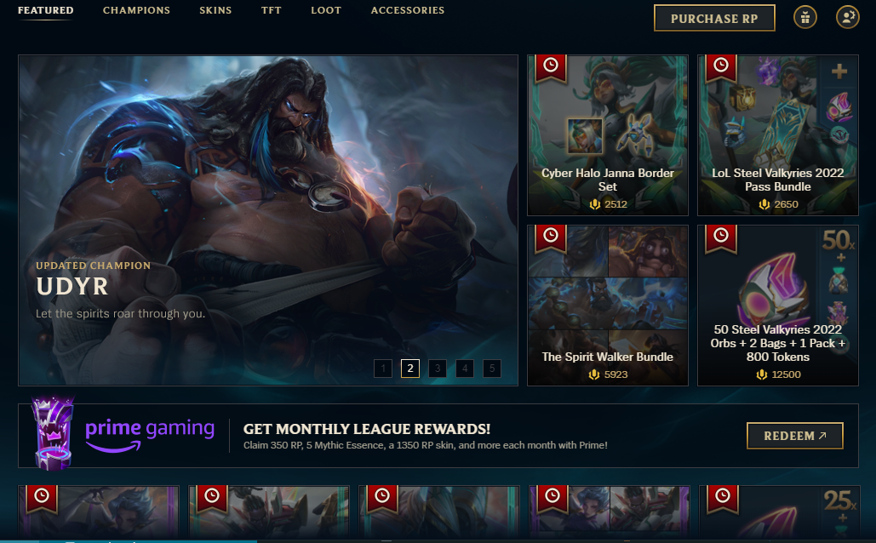

Below we can see themed rows of tiles, first row is for timed sale items, second row is for skins, so an aesthetic purchase, then from there it is more timed items and sale items. This whole “Featured” landing page is designed to get the users to buy what they want them to buy, with sales, new items etc. This is really great as these items change all the time, so it is a fresh look every few days/week.

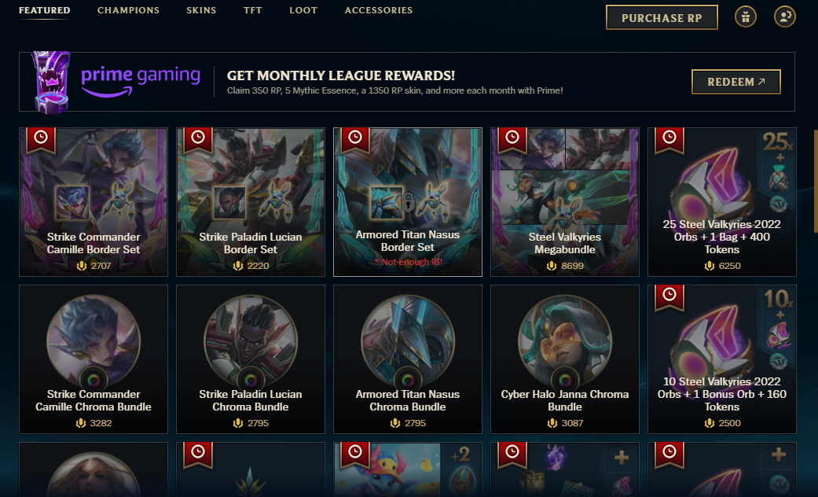

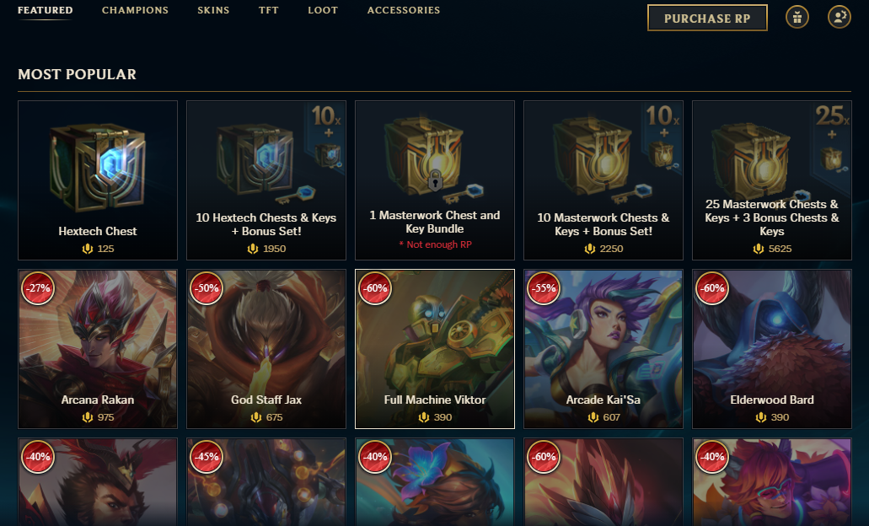

## Items Page

This page is where items are displayed for sale. What I love from this example below, is the ability to be able to select a check box to narrow down results, or to search for items by their metadata, so name, type, price, on sale etc.

I have also added in some examples from OpenSea, eBay and Amazon, which all use the same layout. Items on the right, then an easy to use navigation bar on the left.

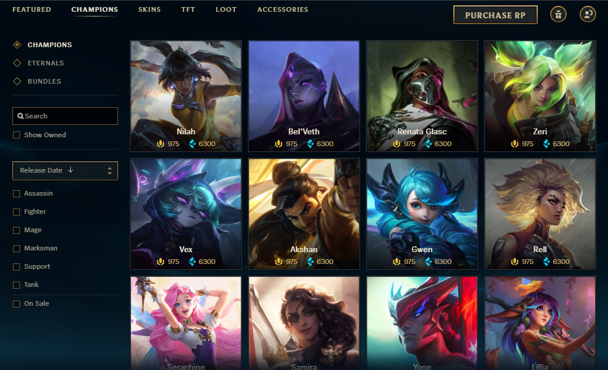

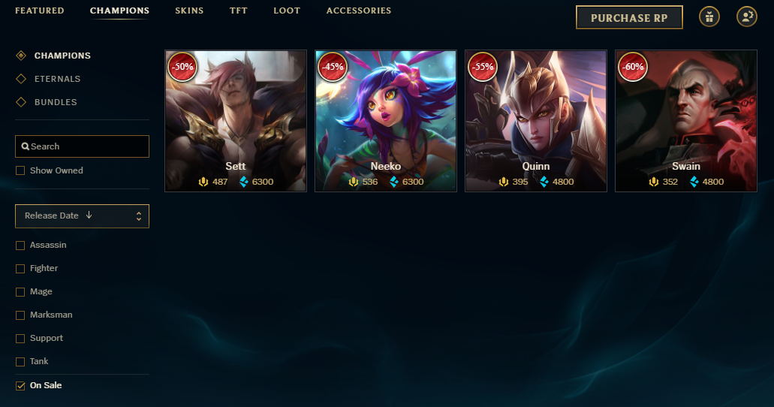

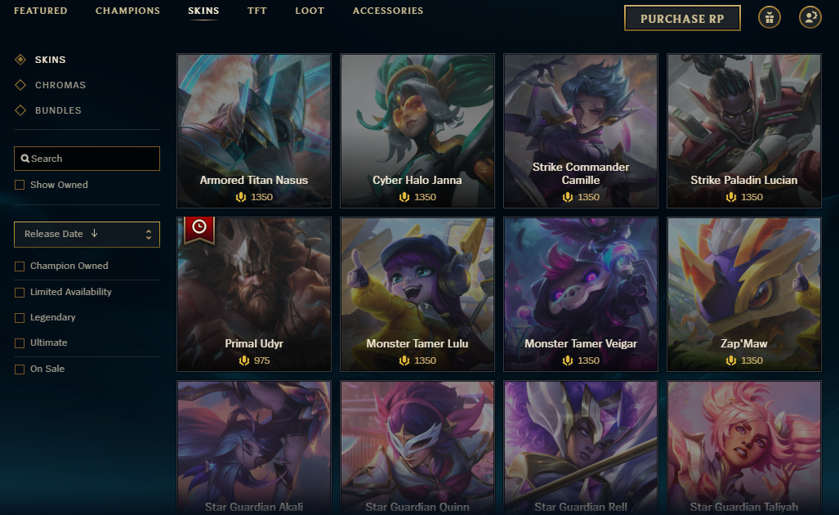

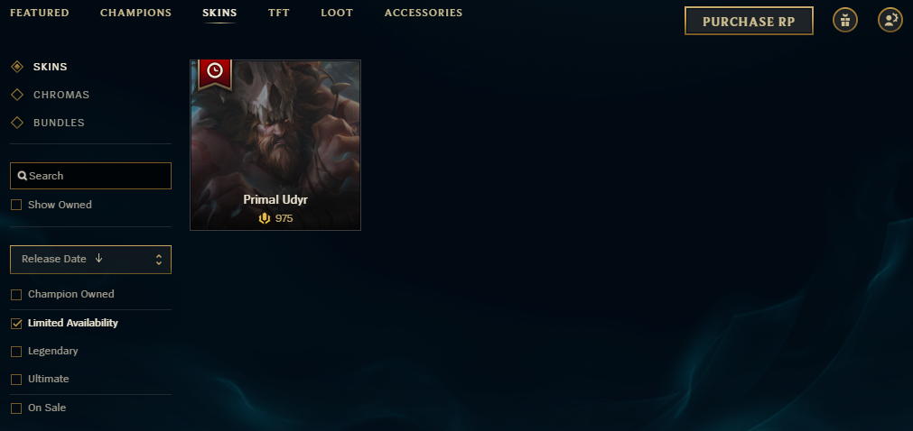

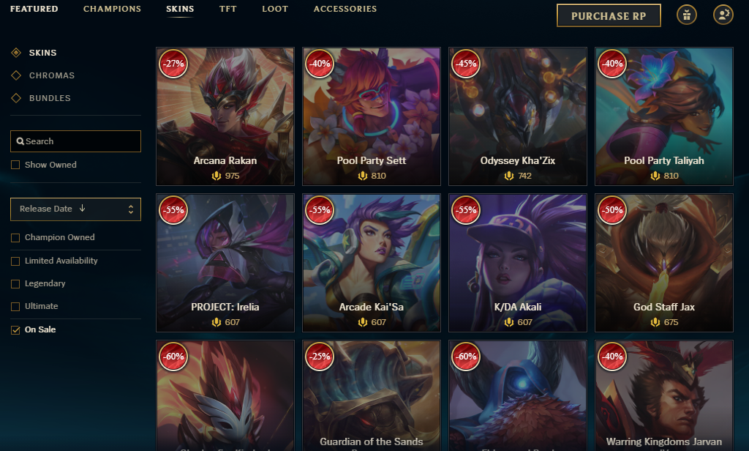

## 

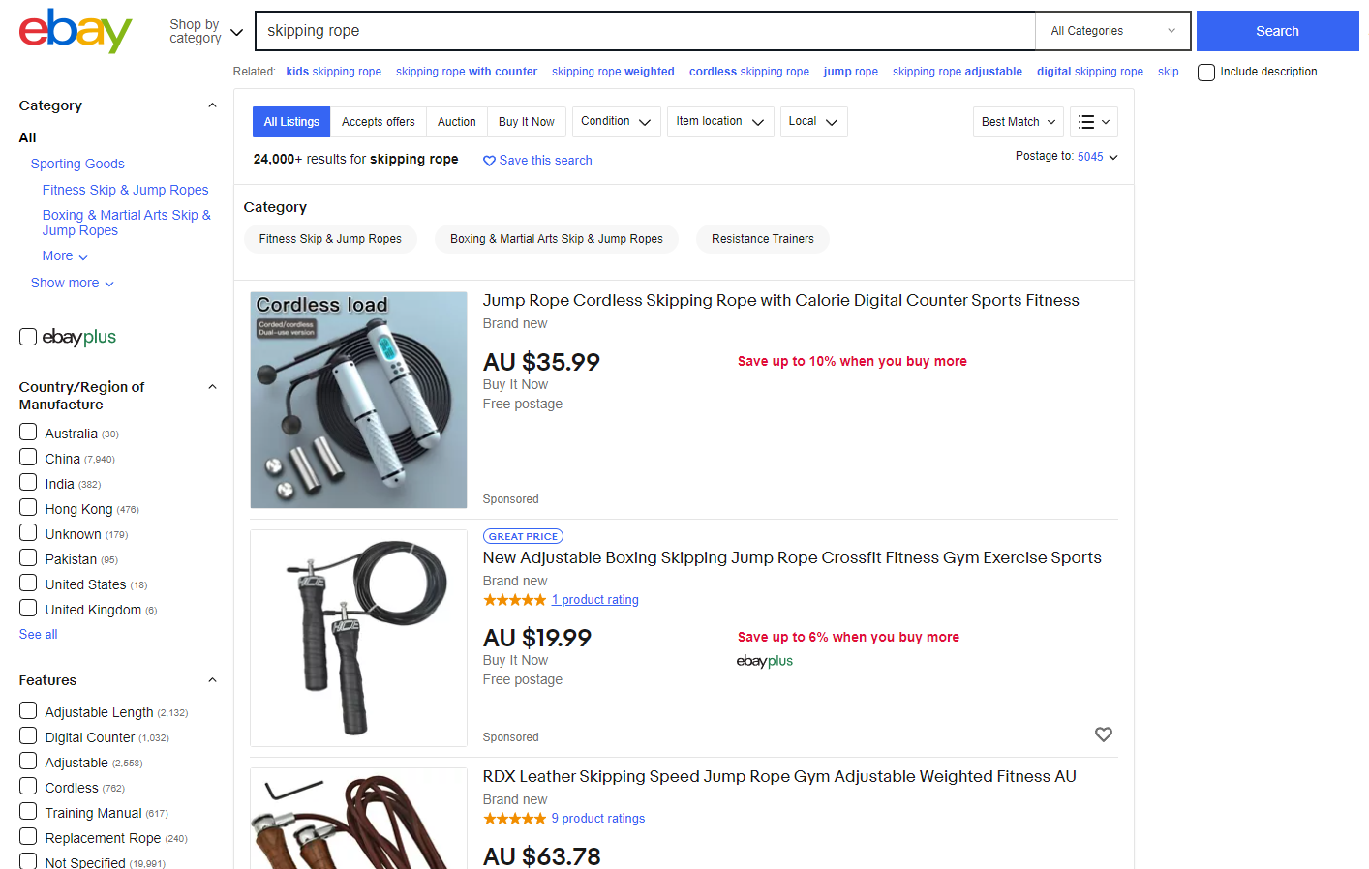

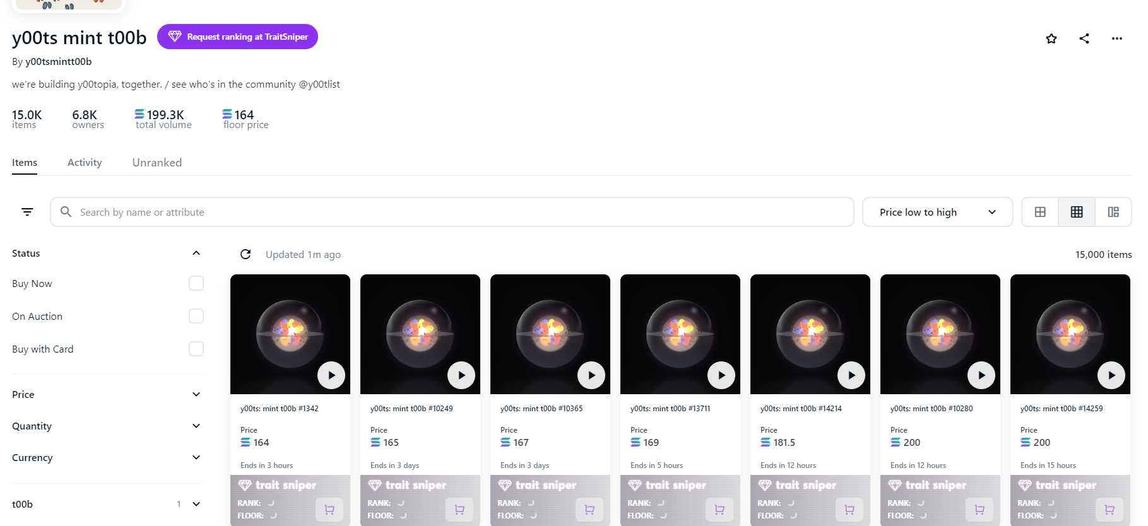

## Item Colouring

Based on an item’s rarity, the colour of the typeface will change. This allows for anyone, at a glance, to see the rarity of someone’s items just based on the text colour, like in World of Warcraft, example below:

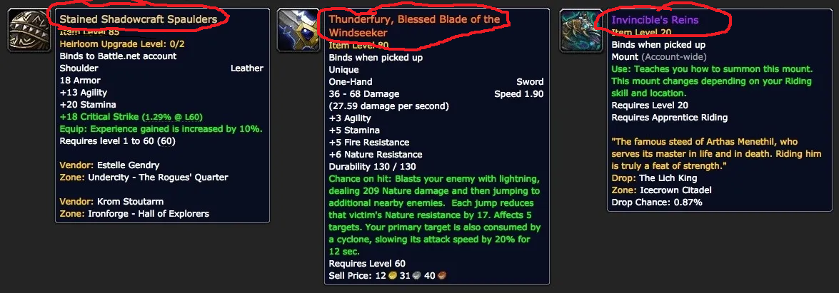

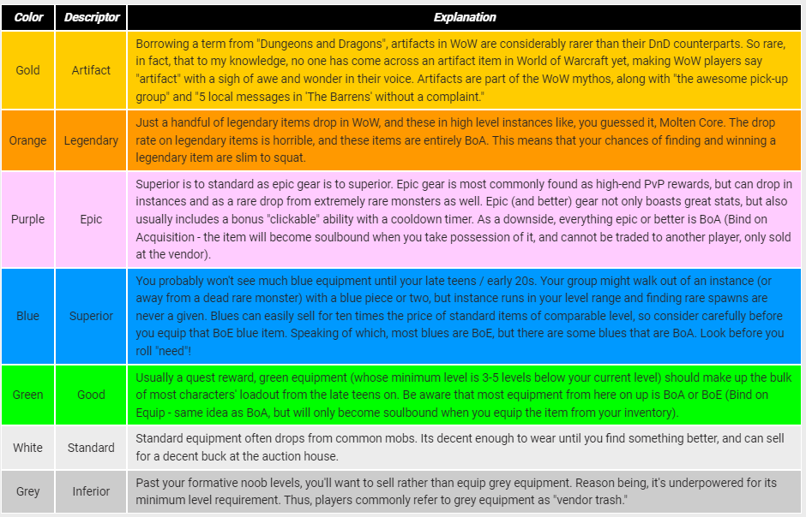

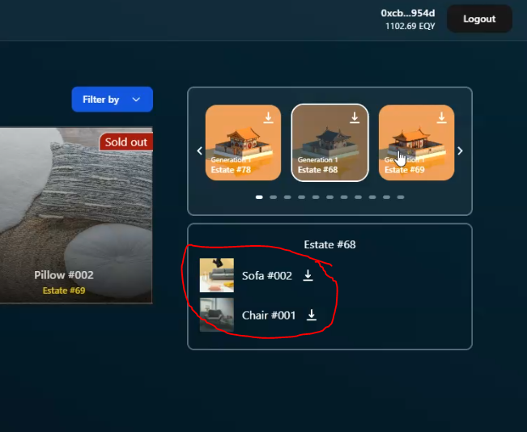

## Item Ownership Page

This is where users can go to see what they currently own. At the moment this page is called the “Inventory” on our existing GUI. There still should be the ability to navigate this page by metadata, like on the previous page.

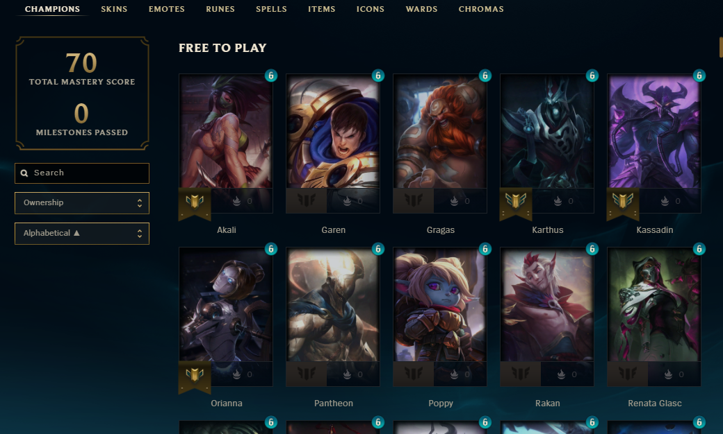

## Item Parameters

Colour: Fine as is

Rarity: Fine as is

Type: Fine as is

Description: Fine as is

Quantity: Can be any number, or if left blank then unlimited

Sale %: Will reduce the price and show the percentage reduction along with the new price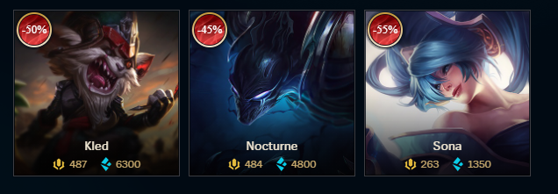

Sale/availability timeframe: This is where we can define how long an item is available for purchase, or how long it is on sale for. For example, Item A is Christmas themed and is available only for the month of December, so we can set a timeframe from 1st December to 31st December for availability time window. After the 31st of December it automatically changes to Sold out.   
Item B is on sale at 50% for the next week. So we can set a sale window from 5pm 21/10/22 to 5pm 28/10/22 for Item B to be at a reduced price, after which it automatically reverts to its normal price.

## Workflow

For the carousel, I would like the image to change **every 4 seconds**, and there be the option of having up to 5 different tiles in the carousel.

The workflow will be that on the admin panel, there should be 5 parameters for each tile. The three headings are like this example

Type Heading →

Main Heading →

Subheading →

Then an upload link for the image, and a hyperlink for when someone clicks on the tile.

For the other tiles to the right and below, in the admin panel it would be good if these tiles were simply numbered and an item could be selected from a dropdown list with search functionality. For example.   
  
Tile 1: White Pillow 1

Tile 2: Red Chair

Tile 3: Yellow Furniture Bundle

Tile 4: Orange Furniture Bundle (On sale)

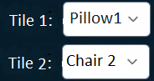Like this

In this way, if an item is on sale, or being sold for a limited time window as described above, this should automatically update. Effectively, this is just selecting four items from the store and showing them here also.

